Machine Learning Project for National Institute of Diabetes and Digestive and Kidney Diseases (NIDDK)
Yakupitiyage Iresha Primali Wimalasiri

Executive Summary

This report explores how machine learning detects diabetes early using medical data from the Pima Indian community. It compares five models to and findings show that Logistic Regression is the best, and glucose levels and BMI are main indicators of diabetes. The report also discusses challenges and way to mitigate them. This kind of AI system could help doctors identify high risk patients early and take care of them.

1. Introduction
1.1 Background
The National Institute of Diabetes and Digestive and Kidney Diseases (NIDDK) is a government research organization in the United States. The goal of NIDDK is to improve people’s health and quality of life through identification of diseases such as diabetes, kidney, and digestive problems. NIDDK helps doctors in identification of these illnesses to prevent them early.
The dataset used in this study comes from the Pima Indian community in Arizona, a group known as highest rates of Type 2 diabetes in the world. This community was chosen because their records help to understand how diabetes develops and factors increase the risk.

1.2 Business Problem
Healthcare providers face challenges in early identification of patients resulting in a high risk of developing diabetes due to limited resources and inconsistent diagnostic practices. Hence there is a high chance of an increasing number of patients in Arizona. This delay often results in higher treatment costs and reduced patient quality of life.

How AI help?
Healthcare institutions depend on data driven technologies such as Artificial Intelligence (AI) and Machine Learning (ML) to identify disease. By applying ML techniques NIDDK aims to detect diabetes earlier.
Therefore AL and ML are essential and relevant to this situation because it helps to forecast the likelihood of diabetes based on patient data rather than waiting for symptoms to come.

Main Goals
This study aims to use ML in Orange Data mining software to identify factors and patterns that cause diabetes. By testing different models such as Logistic Regression, Neural Network, Random Forest, k-Nearest Neighbour (kNN), and Support Vector Machine (SVM), the project focuses to,
- Detects diabetes earlier and more accurately.
- Identify high risk individuals before symptoms.
- Optimize resource allocation in hospitals.
- Reducing human errors.

2. Methodology
2.1 Data Collection
The dataset for this project was sourced from Kaggle, originally provided by the National Institute of Diabetes and Digestive and Kidney Diseases (NIDDK) in the United States. It contains medical records of women aged 21 years who were part of a long term health study on diabetes.
The dataset includes 768 entries with eight health measurements which are highlighted in green in the data table. The target column, called Outcome, indicates whether a person has diabetic (1) or not (0).
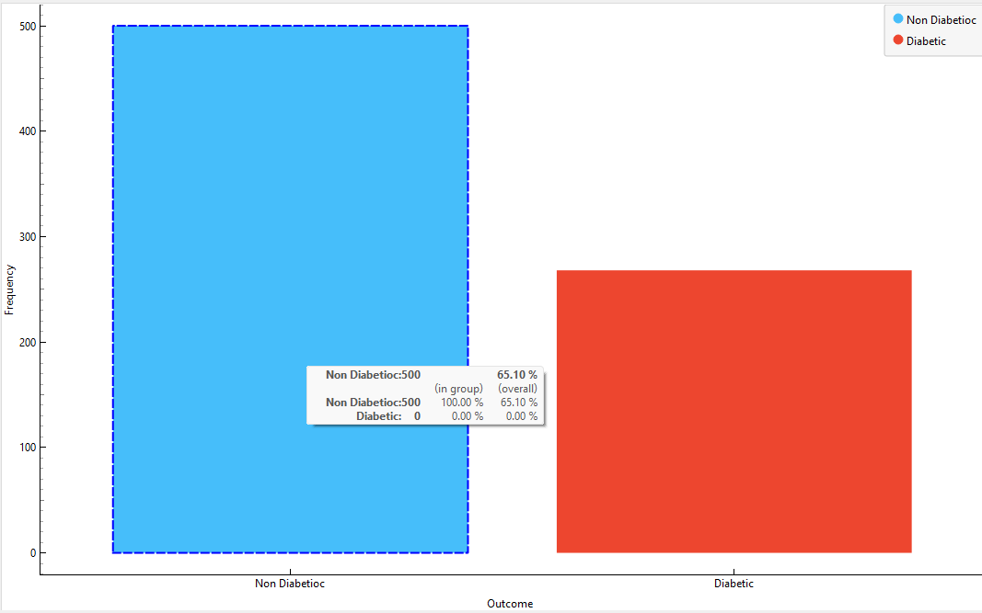

URL of Dataset ; https://www.kaggle.com/datasets/nancyalaswad90/review/data

2.2 Data Preprocessing
These preprocessing steps ensured that the dataset is clean, well structured, and ready for analysis. Overall, the preprocessing process improved the quality of the results.
Edit Domain
The Edit Domain widget was used to correctly define the outcome with two values. This transformation improved model interpretation by clearly labeling the results.
0 = Non Diabetic
1 = Diabetic
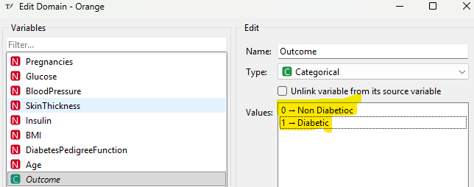
Select Columns
we remove unnecessary columns and ensuring that only the selected features such as Pregnancies, Glucose etc were used for training the models. We set Outcome as the target variable.
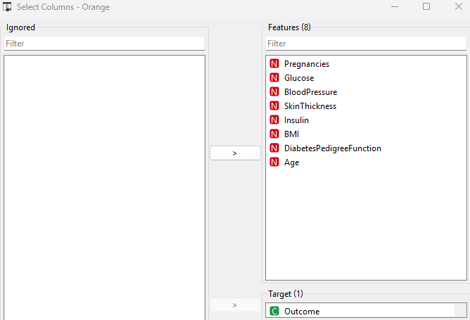

Data Sampler
This widget was used to split the dataset into training (80%) and testing (20%) subsets. The training data was used to teach the model while the testing data was used to check how well the model can make predictions.
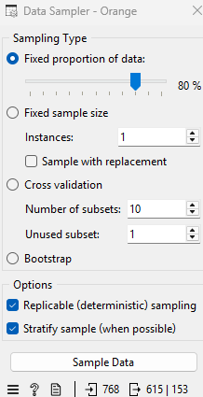
Box Plot
The dataset was reviewed for outliers. These four variables Age, Glucose, BMI and Pregnancies are the most significant predictors. The smaller the p-value, that variable influences diabetes.
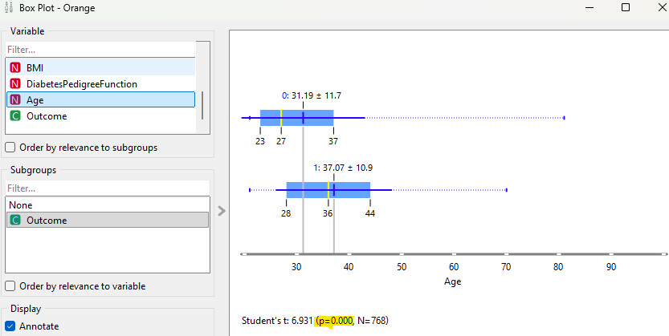

2.3 Model Selection
In this project, suitable predictive models were identified and built using the Orange. Based on the nature of the target variable, several supervised machine models were applied, including Logistic Regression, Neural Network, Random Forest, k-Nearest Neighbour (kNN), and Support Vector Machine (SVM).
- Logistic Regression
Logistic Regression was used because it is best for binary classification, predicting whether a patient has diabetic (1) or non diabetic (0). It works well with numeric medical data and shows how each factor influences diabetes risk.
Logistic Regression was kept without regularization to maintain interpretability and accuracy, as the dataset is not very large.
- Random Forest
The Random Forest model was chosen because it can handle many health factors like glucose, BMI, and age. Using 1000 trees made the results stable, and a depth of 4 prevented over fitting. This setup gave good accuracy (0.778) and helped identify diabetic patients effectively.
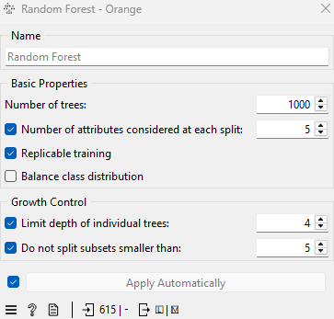

3. Neural Network
This model learns patterns between medical factors to predict diabetes accurately. It has two hidden layers (10, 10) to capture relationships without over fitting. ReLU helps the model learn faster and 500 iterations allow it to reach stable results.
4. K-Nearest Neighbour (KNN)
The KNN algorithm was selected because it is simple and works well for medium sized numeric datasets like the Pima Indians Diabetes dataset, KNN model tries to find patterns by comparing each patient to similar cases in the dataset.
5. Support Vector Machine (SVM)
This model works by finding the best straight line with the largest possible gap that separate diabetics and non diabetics. Hence SVM tries to make it as wide as possible to classify patients more confidently.

2.4 Training and Validation
The dataset was divided into 80% for training and 20% for testing using the Data Sampler widget. The training data helped the models learn patterns, and the testing data checked how well the model could predict, unseen records after training.
Hyper parameter was carried out for each model to improve performance.
- Neural Network: 2 hidden layers (10, 10), ReLU activation, 500 iterations.
- Random Forest: 1000 trees, maximum depth = 4, minimum split size = 5.
- KNN: 5 neighbors, Euclidean distance.
- SVM: Linear kernel, cost = 1.0, complexity bound = 0.5.
These parameters were selected after testing different values and balance accuracy and no over fitting.

3. Results
3.1 Model Performance
The models were evaluated using metrics such as Accuracy (CA), Precision, Recall, F1 score, AUC, and MCC to measure how well they predicted diabetes. These values show how effectively each model identified diabetic and non diabetic patients in the dataset.
Overall Performance
Below results shows general performance of all models together.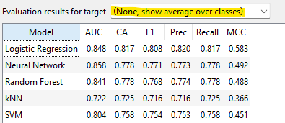

Diabetic Class
This table shows the performance of all models in correctly identifying diabetic patients, based on key metrics.
For predicting diabetic patients, Neural Network performed the best in terms of AUC (0.858) and Recall (0.778).
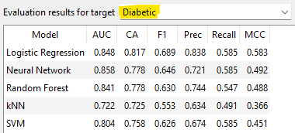

Non Diabetic Class
This table shows the performance of all models in predicting non diabetic patients, highlighting how accurately each model identified healthy individuals. Logistic Regression remains the most stable with highest recall 0.940.

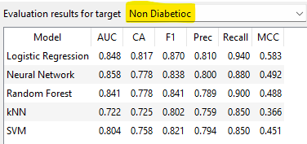

3.2 Comparison of Models
When comparing the five Logistic Regression and Neural Network performed the best. Logistic Regression gave the highest accuracy (0.817) showing it works well overall. The Neural Network had the highest AUC (0.858), it is good in separating diabetic and non diabetic patients.
Random Forest gave good accuracy but lower precision due to over fitting. SVM was stable but less sensitive to diabetic cases, while KNN performed the weakest with the lowest accuracy.
Confusion Matrix to compare
Further confusion matrix for the Logistic Regression model confirms highest accuracy. It correctly identified 94 non diabetic and 31 diabetic patients.
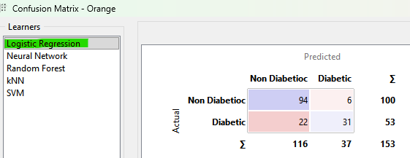

The Neural Network correctly predicted 88 non diabetic and 31 diabetic patients. It performed slightly lower than Logistic Regression.
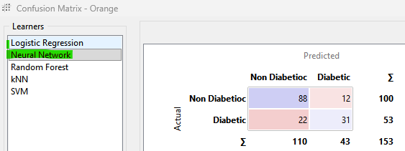
The Random Forest correctly classified 90 non diabetic and 29 diabetic patients.
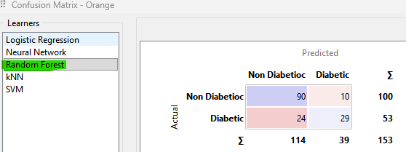

The kNN model correctly predicted 85 non diabetic and 26 diabetic cases. Model struggles to separate diabetic and non diabetic patients as clearly as the other models.
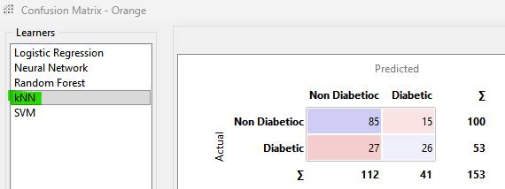

SVM correctly predicted 85 non diabetic and 31 diabetic patients. The results are closer to Neural Network but not the best.
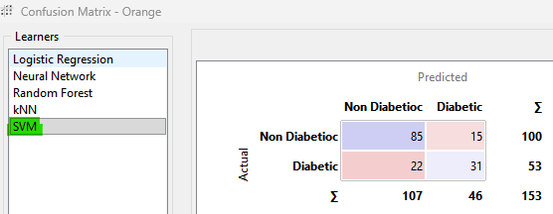

Use ROC to compare
This ROC curve helps to see how well each model can correctly identify diabetic patients without making many mistakes.
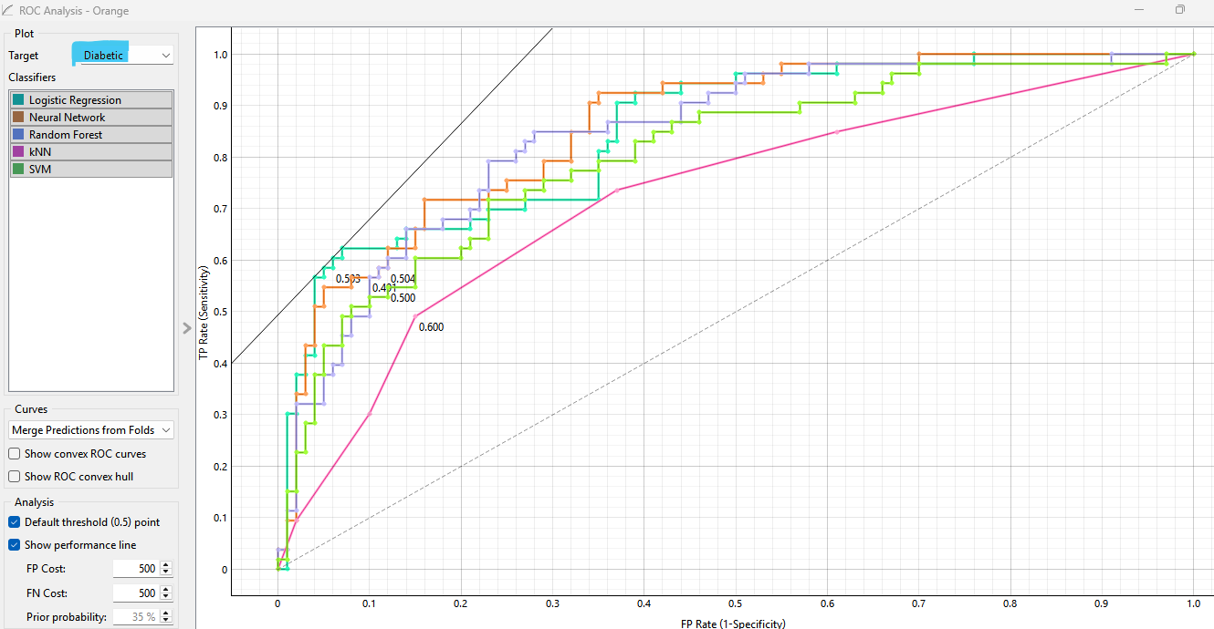

Logistic Regression (blue) and Neural Network (orange) have the highest curves in diabetics model, meaning they are better at detecting diabetes correctly.
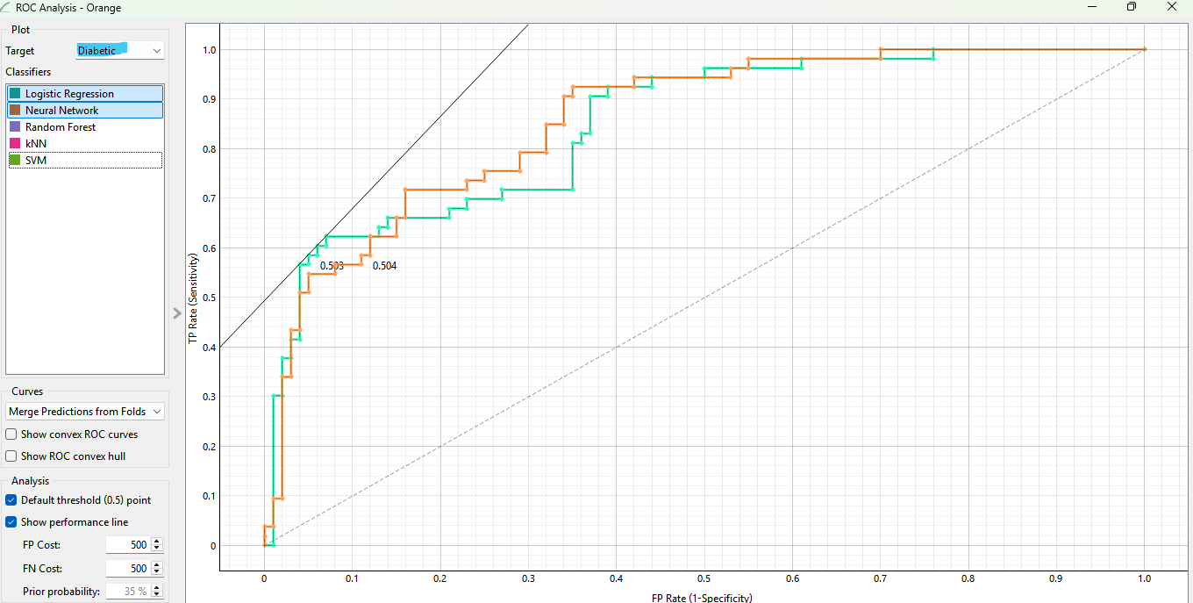
In below non diabetics’ model also Logistic Regression (blue) and Neural Network (orange) curves are highest, means identifying non diabetic patients correctly which helps to prevents unnecessary cost.
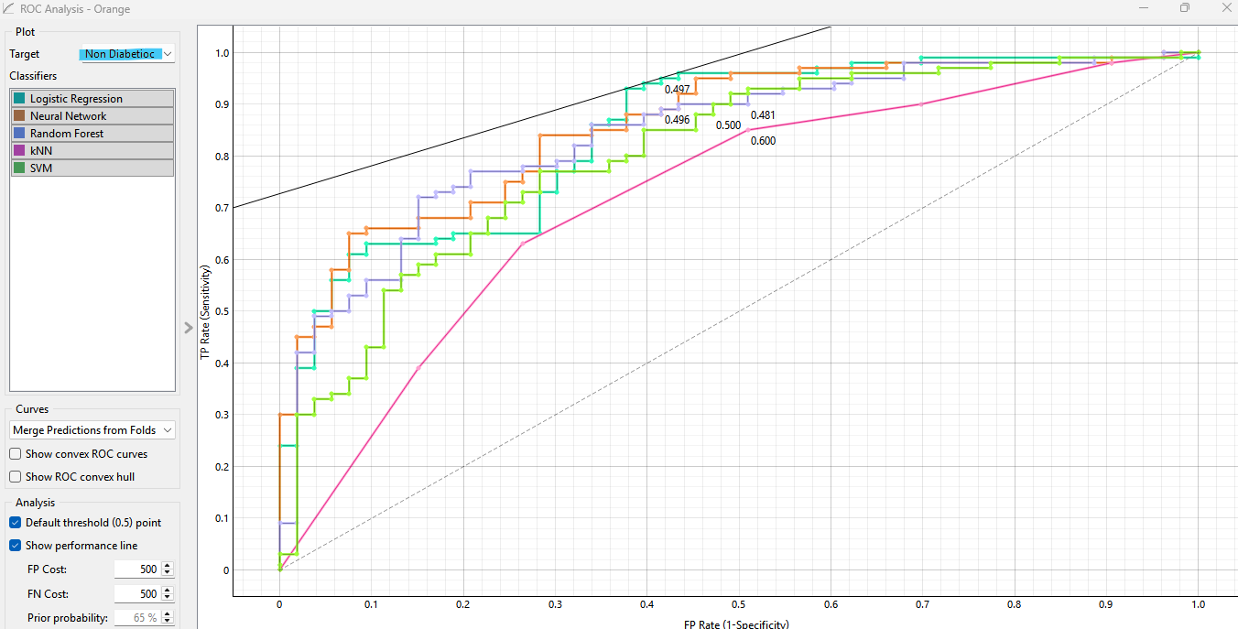
In summary, using different models Logistic Regression performed the best among all models.

3.3 Visualization of Results

Feature Importance
This widget helps in understanding which features are most influential for the model’s decisions.
According to the below charts if we consider top three features, glucose consistently shows as highest importance as it is strongest indicator for diabetic. Body Mass Index ranks second.

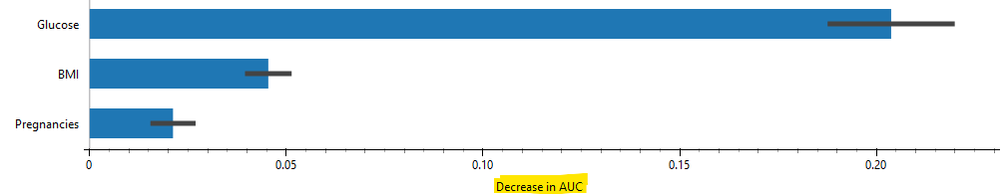

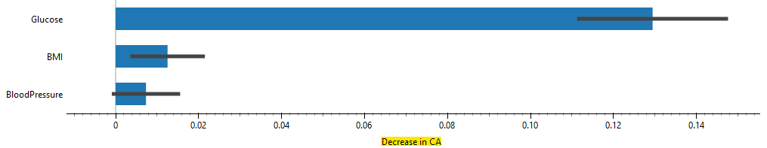
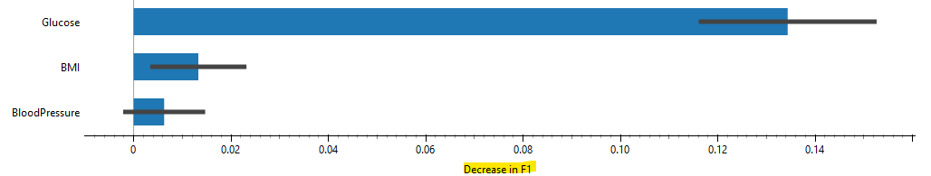
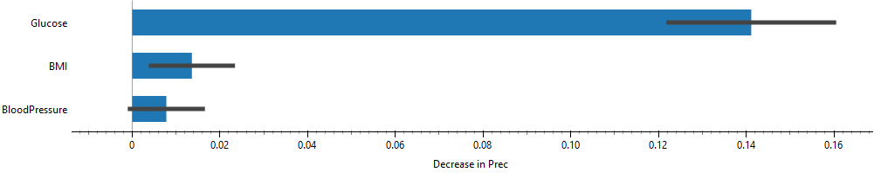
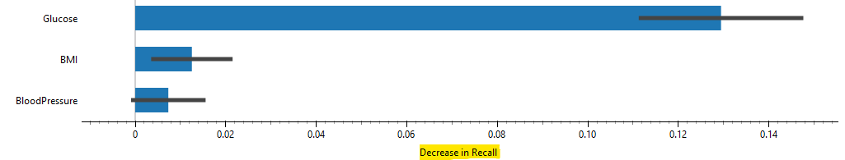

Explain Model
Red dots are on the right hand side, showing positive impact and increase the chance of being predicted as diabetic. When a person’s glucose and BMI are high, the model strongly predicts them as diabetic.
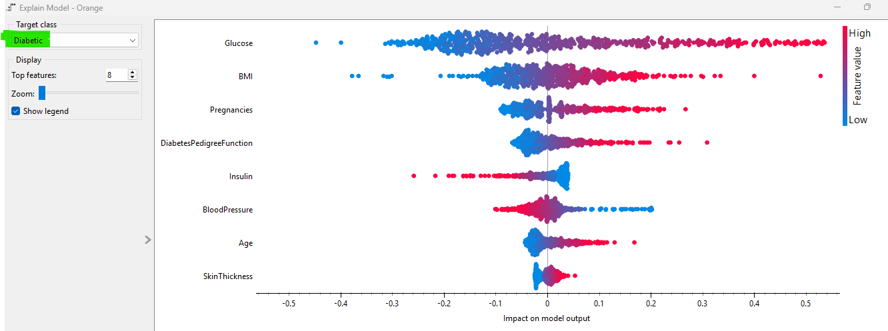

Opposite to the above graph blue dots are mostly on the right side, increasing the likelihood of being non diabetic.
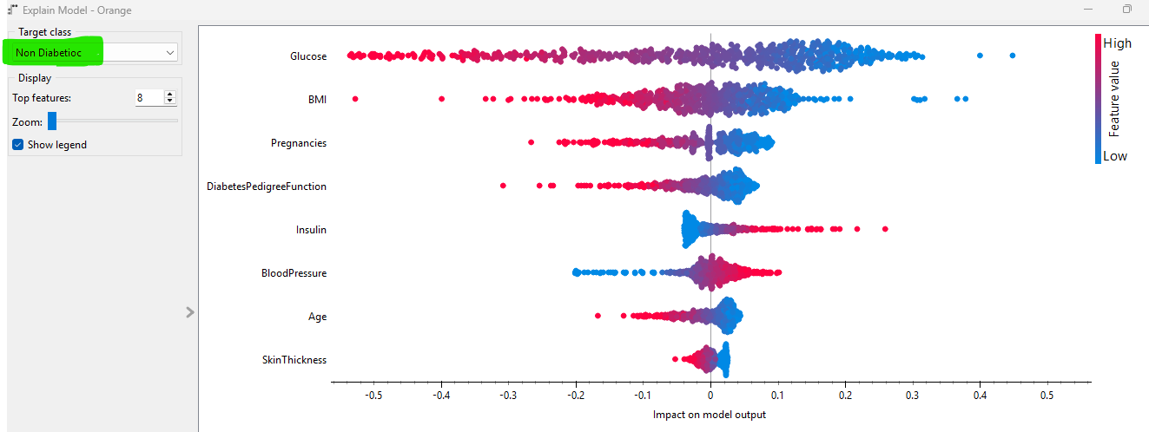

ICE
The ICE plot shows how each feature influence the decision. According to the below graph if glucose levels increase, the model’s predicted risk of diabetes also rises. This clearly indicates that glucose is the most influential factor in predicting diabetes.
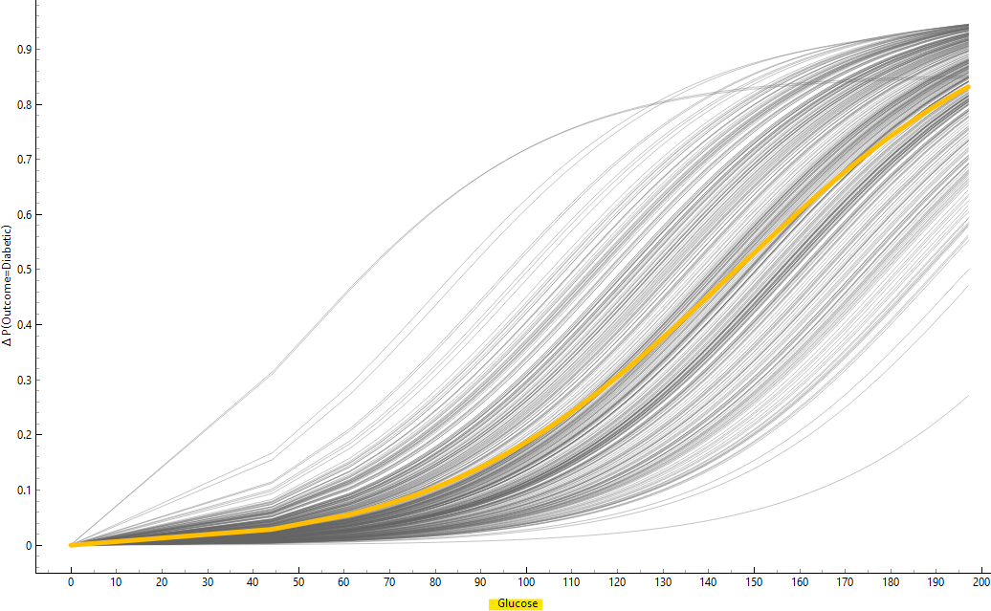

In contrast, below opposite graph shows blood pressure alone is not a strong indicator of diabetes, but it may effect when combined with others like glucose.
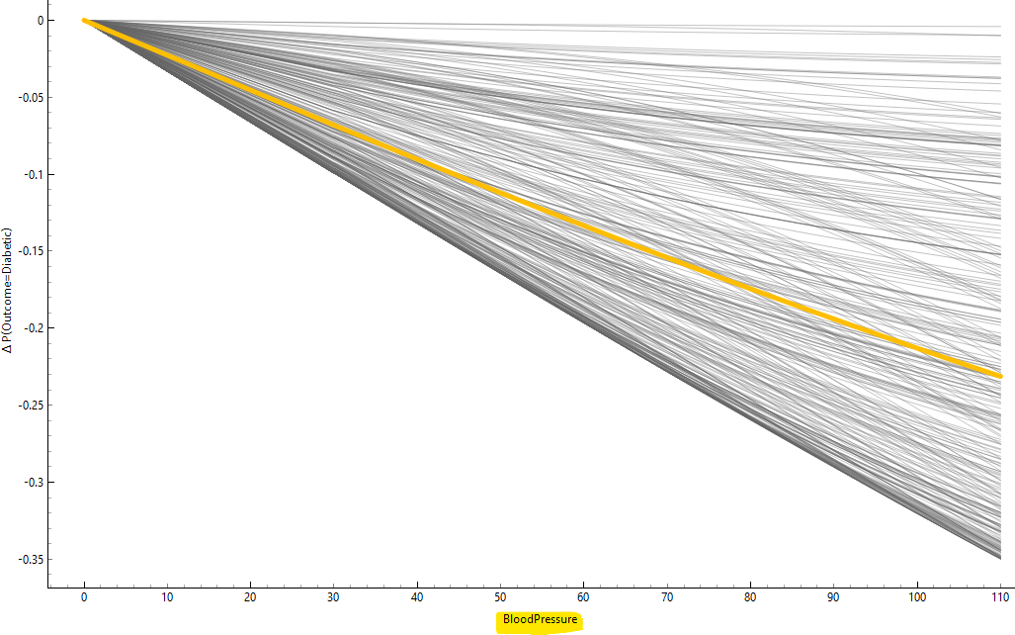

Explain Prediction
This shows how much each feature contributes to the final prediction for individual cases. In this case we test on patient 7 health data, glucose is 183, the model to predict a high probability (87%) of being diabetic. On the other hand, the non-diabetic model gave a very low prediction of 13%, shows unlikely for this person to be non diabetic. Overall, the model shows high glucose high chance for diabetes.

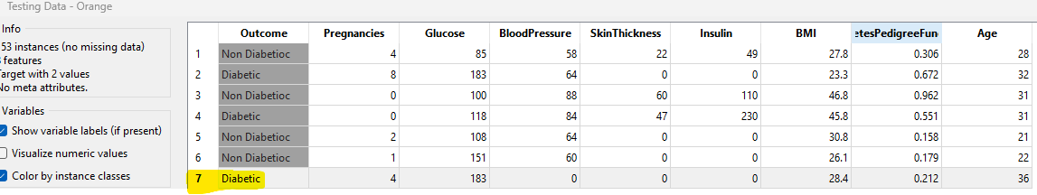
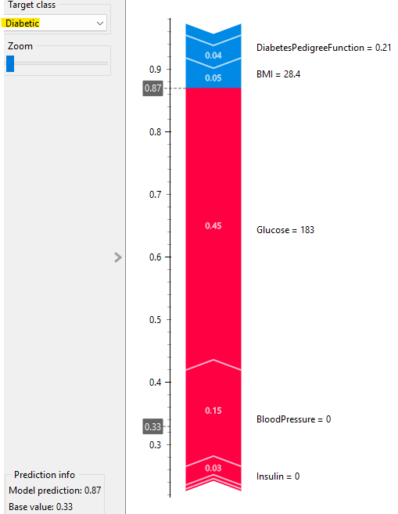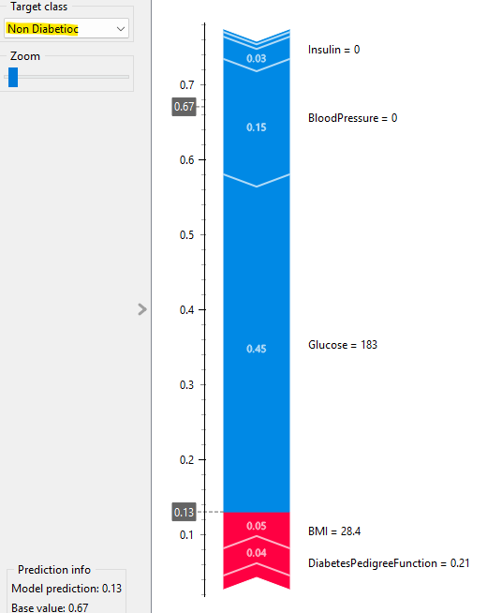

4. Discussions
4.1 Interpretation of Results
• Logistic Regression was the best overall model according to the ROC, Confusion matrix and with the highest accuracy and balanced results for both diabetic and non-diabetic patients.
• Neural Network also performed well, achieving the highest AUC (0.858), meaning it can clearly separate diabetic and non diabetic cases.
• The feature importance results showed that glucose is the most influential factor and BMI is next best.
• The Explain Model graphs showed that when glucose and BMI are high, the chance of being diabetic increases sharply.
• The ICE plot clearly showed that higher glucose values directly increase the risk of diabetes, while blood pressure alone has a smaller impact.
Overall, the findings match real world medical understanding high glucose and BMI are the main signs of diabetes, and Logistic Regression provides the most reliable and accurate predictions for clinical use.

  - Limitations

- Small Dataset and represents one community
The dataset is small in size (768 records only) and specific to one community, so the results might not represent all populations.
- Imbalanced Classes
There were fewer diabetic cases 65.10%. This imbalance can make different models to predict non diabetic more often.
- Missing Variables
The dataset did not include important factors like diet, exercise and family medical history. These limit the model’s ability to capture the full picture.

Misclassification Risk
If a diabetic patient is mistakenly classified as non-diabetic, it could delay treatment and lead to serious health complications.

Areas of Improvement
- Expand and balance data
Collect larger and diverse records from different regions, age, and backgrounds. Collect more data for diabetic patients so the model can learn better. This will help to predict accurately.
- Add more Variables
Add lifestyle and family related data such as diet, exercise and family history.
- Test in real world to avoid misclassification
Regular testing with real hospital data and expert validation would also help ensure safer and more reliable results in practical healthcare settings.

4.3 Future Work
In the future, this project can be developed into a practical tool for NIDDK to support early diabetes detection. By expanding the dataset the system could help doctors identify patients at risk earlier and reduce long term treatment costs.
Early diagnosis can lower hospital expenses by approximately 15–20%, as it prevents serious complications that require expensive care. This could save thousands of dollars per patient each year and improve patient outcomes. Hence systems could deliver a return on investment (ROI) of 25–35% through reduced costs.

5. Conclusion
In conclusion, this study showed that machine learning can help detect diabetes early using ML. Among all tested models, Logistic Regression gave the best results, with glucose and BMI being the most important factors. The project proves that AI can support doctors in making more accurate decisions, helping reduce costs and improve patient care.

6. References
- Wilson, H., Valente, E. & da Silva, V., (n.d.) Pamphlet. College of Agriculture and Life Sciences, University of Arizona, Tucson, AZ. Copyright © Arizona Board of Regents
- https://www.kaggle.com/datasets/nancyalaswad90/review/data
orkshop_2025_T2_11_v2.pdf

